Section 3. Political and Economic Situation

It is important for HackerNest to expand to a country that has a strong and stable economy because HackerNest is a non-profit organization that relies on the support of its sponsors and the local government. South Korea is one of the fasted growing economies from the 1960s to the 1990s, and was termed as one of the Asian Tigers. Nowadays, South Korea is ranked as the 12th largest economy in the world.

Real GDP indicates the total amount of goods and services a country produced in a given period of time. South Korea has a real GDP of 1.378 trillion, and a real GDP per capita of more than 27,000 USD in 2015. Comparing to Canada, who has a real GDP of 1.551 trillion and a real GDP per capita of 43000 USD in 2015 (*South Korea Economy: Population, GDP, Inflation, Business, Trade, FDI, Corruption*), South Korea’s economy is not as developed as Canada’s economy (See Appendix B, Figure 1 for GDP per capital of South Korea and Canada). Thus, HackerNest should be aware that they may earn less than they did in Canada. However, South Korea has a GDP growth rate of 2.61% in 2015, which is more than twice of the GDP growth rate of Canada (*South Korea Economy: Population, GDP, Inflation, Business, Trade, FDI, Corruption*) (See Appendix B, Figure 2 for GDP Growth of South Korea and Canada). The GDP growth rate exemplifies that South Korea’s economy expands faster than Canada’s economy, and the income that HackerNest’s South Korea subsidiary make will most likely to grow at a higher rate. HDI is a crucial economic indicator as it considers health, education, and income. The HDI of South Korea is 0.90, and the HDI of Canada is 0.92 (*Human Development Reports*). This set of statics reveal that there is no huge difference between the two country’s life expectancy, education, and personal income. In fact, the life expectancy of both countries are approximately an impressive 82 years (*South Korea Economy: Population, GDP, Inflation, Business, Trade, FDI, Corruption*) (See Appendix B, Figure 3 for Life Expectancy of Canada and South Korea). Unemployment rate is another economic indicator. In 2016, the unemployment rate in South Korea is 3.5%, which is 3.4% lower than the unemployment rate in Canada (*Trading Economics*). Since a higher percentage of the labour force is employed, HackerNest has little choice of who to employ, and needs to provide employees with higher salaries. South Korea’s most current inflation rate, measured in April 2017, is 1.9% (See Appendix B, Figure 4 for Inflation Rate in South Korea). As the figure shows, South Korea’s inflation rate fluctuated between 1.9% to 2.2%. Canada’s inflation rate, as measured in April 2017, is 1.6% (*Trading Economics*) (See Appendix B, Figure 5 for Inflation Rate in Canada). However, the Canada’s inflation rate fluctuated more drastically than South Korea’s in the past year. The average household income in Canada is $ 76,000 (*CBCnews*). However, the average household income in South Korea is only $19,400. This significant difference between the two countries’ household income is a result of the considerable gap between the richest and the poorest in South Korea. To be more specific, the top 20% of the Korean population earn nearly six times as much as the bottom 20% (*Economy*). Based on the statistics and comparison above, South Korea has a developed economy that is growing steadily. Therefore, HackerNest’s subsidy in Seoul is unlikely to be negatively impacted by the nation’s economy.

South Korea operates under a mixed economy. This type of economic system includes a variety of private freedom, combined with centralized economic planning and government regulation (*Global EDGE: Your Source for Global Business Knowledge*). HackerNest’s subsidiary in South Korea would have the freedom to determine what services to offer, how much to offer, and for whom to offer. However, HackerNest must follow the regulations and laws set by the government. In the late 20th century, South Korea transformed itself from an exporter of textiles and shoes into a major global producer of automobiles, electronics, shipbuilding, steel, and high-technology products. The South Korean government encourages the growth of large, internationally competitive businesses through easy financing and tax incentives. The government’s model of encouragement has led to the dominance of the family-controlled conglomerates, which are known as chaebols. (*Santander Trade*). Some of the well-known chaebols are Hyundai, Samsung, LG, and SK Company. Since HackerNest relies on volunteers and sponsors to host hackathons, HackerNest can approach to chaebols that produce high-technology products and ask for sponsorship.

According to the UNCTAD 2016 World Investment Report, foreign direct investment (FDI) flows into South Korea have been more or less constant in recent year. Unfortunately, the FDI is delinking due to unfavourable international economic context (See Appendix B, Figure 6 for Statistics about FDI). For instance, the FDI reached a record level of 12.7 billion in 2013, but fell to 5 billion due to Tesco withdrawing investment. South Korea’s appeal in terms of foreign direct investment is the result of the country’s rapid economic development, highly skilled workforce, high quality infrastructure, and specialization in new information and communication technology. Additionally, the strong shipping and air cargo infrastructure makes South Korea a great hub for expansion into other markers. While HackerNest is experiencing those advantages, it may also suffer from the following drawbacks. For example, the lack of general transparency in regulation is a major concern, the cost of labour is comparatively high, frequent contract negotiations throughout a business relationship are common, and real estate is expensive (*Santander Trade*). To eliminate drawbacks, HackerNest should publish a code of conduct that explains how employees should respond in different situations. South Korea has signed a series of treaties with other country. The free trade agreement between South Korea and Canada has been forced since January 2015 (*Free Trade Agreement Between Canada and the Republic of Korea*). This agreement makes it easier for HackerNest to expand to Korea. South Korea’s foreign direct investment procedures consist of 4 stages: foreign investment notification, remittance of investment funds, registration of incorporation and business, and registration of foreign-invested company. The South Korean government has implemented measured to protect and encourage foreign investments. Though there are many prohibitions on investment in specific sectors of public administration, educational organizations, and national defence, the government offers FDI tax support such as corporate tax and income tax reduction, local tax reduction, and exemption from custom duties. HackerNest should apply for the tax reduction when the business is at its early stage. In addition, HackerNest should also apply for the cash grants provided by the central and local government. This grant will cover some portion of the land purchase expense, lease expense, and employment/training expense (*Invest Korea*).

Corporate tax is the tax base for South Korean residents and foreign companies. Residents are subject to tax on worldwide income, while non-residents are only subject to tax on Korean-sourced income (See Appendix B, Figure 7 for Corporate Tax Rate). Foreign corporations with a permanent establishment in Korea pay standard corporate income tax. While foreign corporations without a permanent establishment are taxed at rates ranging from 2% to 20%. There is also a taxation on capital gains. For non-resident companies like HackerNest, Korean-source capital gains are taxed at either 11% of sales or 22% of gains. Other taxes associated with corporations are capital registration tax, property tax, nominal stamp duty, and acquisition tax. To avoid paying huge amount of tax to both Canada and South Korea, HackerNest should look into the double taxation treaty between the two countries (*Santander Trade*).

Recently, due to the South Korean presidential scandal and the re-election of president, the nation’s economy was hit. According to CNBC news, the leader of Samsung group is arrested because of his connection with an influence-peddling investigation involving the last president. To be more specific, Samsung provided 30 billion Korea dollar to a business and foundations backed by President Park Geun-hye’s friend, in exchange for the national pension fund’s support for a 2015 merger of two Samsung affiliated (*CNBC*). This article in recent news exemplifies the power of chaebols in South Korea. On the one hand, the government relies on the chaebols to support businesses and residents. On the other hand, the chaebols provide money to the government in exchange of regulations and policy in their favor.

Overall, the South Korean economy is characterized by moderate inflation, low unemployment, a rapid economic growth, and an export surplus. South Korea continues to maintain global competitiveness, and has been opened to foreign direct investment. South Korean economy’s long term challenges include an aging population, dominance of chaebols, and the heavy reliance on exports. Luckily, the Korean government has prioritized structural reforms, deregulation, promotion of entrepreneurship to address those long term challenges and sustain economic growth.

The Constitution of the Republic of Korea calls for a liberal democratic political system. Its principles are based on the sovereignty of the people (See Appendix B, Figure 8 for South Korea Political Hierarchy). The political leader is Moon Jae-in, who was elected in May 2017 to replace Park Geun-hye, who was impeached in an influence-peddling scandal. The political leader, also called the president, plays several major roles. First, the president is head of state, leading the government and representing the nation in foreign relations. Meanwhile, the president has the duty to uphold the constitution and protect national independent and territorial integrity. Furthermore, the president needs to carry out tasks of attaining a peaceful unification of Korea (*South Korea - an Elaborate Country Profile*). South Korea has a multi-party system. The four main parties are New Frontier Party (a conservative party), Minju-dang (considered as a liberal party), People’s Party (center leaning), and Justice Party (left to far left leaning). There are many additional small parties in Korea as well, such as Labour Party, Republican Party and so on (*South Korea - Korea4expats*).

Recently, the political situation in South Korea is not quite stable. In 2015, the South Korea political stability index is only 0.1 (-2.5 being the weakest and 2.5 being the strongest) (*TheGlobalEconomy.com*). In 2016, a political scandal in South Korea sent hundreds of thousands of protestors into the streets and has cost past president Park’s impeachment. The political scandal surrounded Park’s friend and informal adviser, Choi Soon-sil, who is accused of abuse of power and attempted fraud. Following claims stated that Park had access to secret government documents and intervened in state affairs (*CNN*). Due to the political scandal, president Park was impeached in December 2016. It was not until May 2017 that Park’s presidency was replaced by President Moon. With the appointment of a new president, there might be potential changes in government policy, specifically policy towards trade and foreign investment. HackerNest should stay updated with the political and economic news in South Korea and stay on top of the changes. President Moon is a member of the liberal party. He has promised to reform South Korea’s chaebols. This potential reformation might influence the trade of high-technology products and automobiles. However, since chaebols play a huge role in South Korea’s economy, there might be a potential economic growth in the future (*The Guardian*).

Corruption Perceptions Index ranks the level of corruption that is believed to exist in a country. Developed countries typically rank higher than developing nations due to stronger regulations (*Investopedia*). In 2016, South Korea ranked the 52nd out of 176 nations with a score of 53 (*Transparency International*). The CPI of South Korea represents moderate risks for HackerNest to invest and operate in South Korea. To minimize risks, South Korea has established the Criminal Code that criminalizes the main forms of corruption. The Act on Anti-Corruption and the Establishment and Operations of the Anti-Corruption and Civil Rights Commission regulates conflicts of interest and asset disclosure for public-sector employees. Moreover, anti-corruption legislation is increasingly enforced in South Korea. HackerNest should be aware of the Strict limits for hospitality and gift-giving to public officials as the South Koreans recently witnessed the largest corruption and chaebol-bribery case the country has even seen (*GANBACP*).

In conclusion, since there are many recent movements with the political situation in South Korea, HackerNest should be aware of any change in the policy towards trade and foreign investment. Since HackerNest relies on chaebols’ sponsorships, it is essential for HackerNest to observe President Moon’s actions of reforming the nation’s chaebols.

Appendix B.

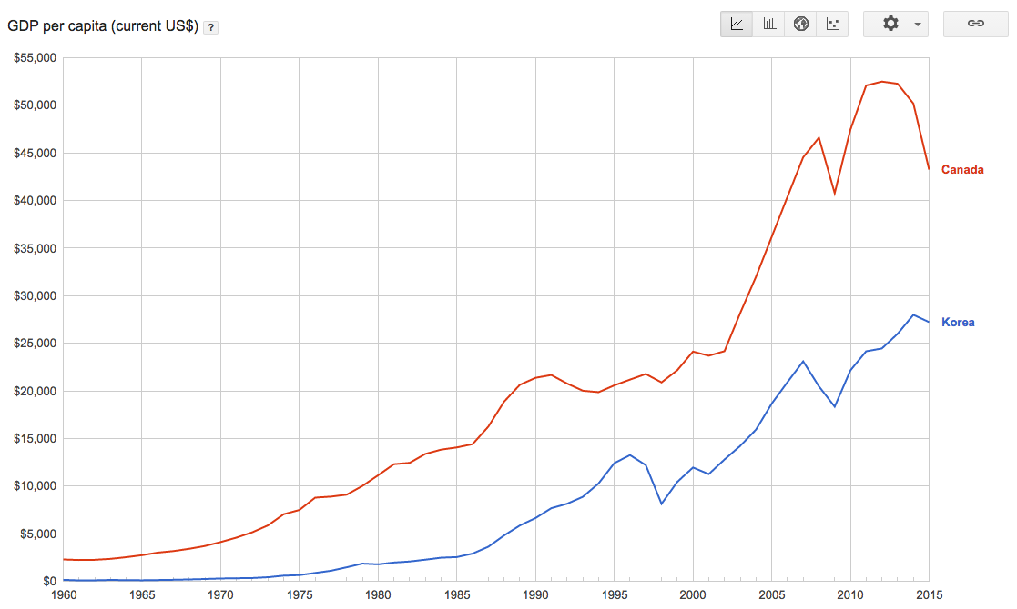

Figure 1.

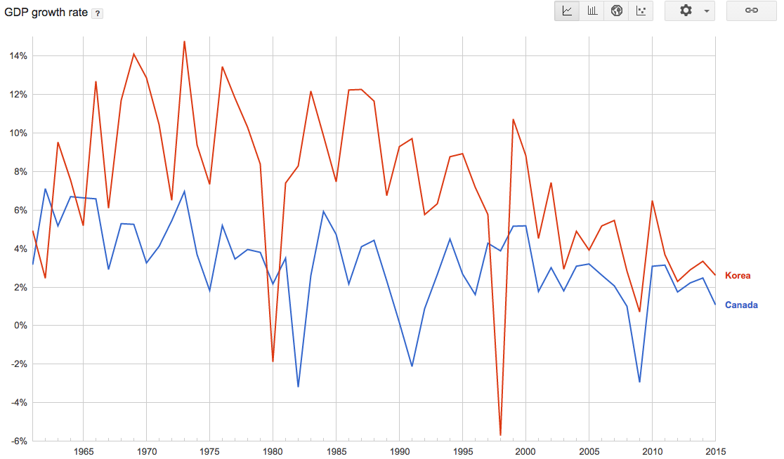

Figure 2.

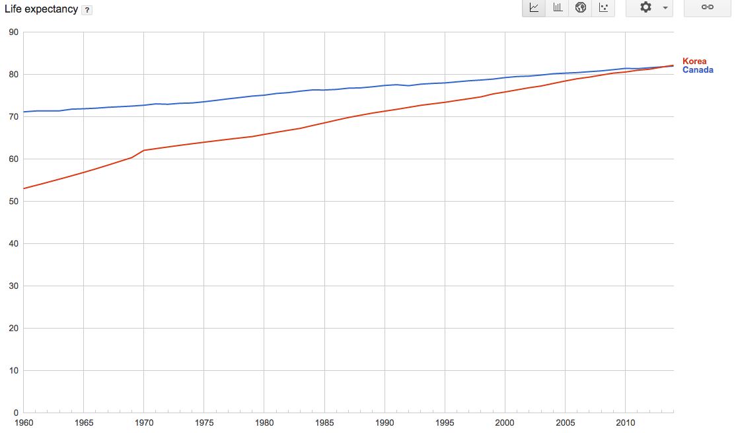

Figure 3.

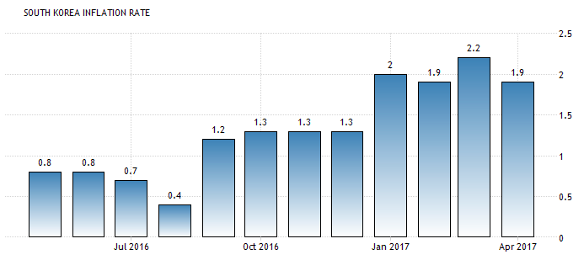

Figure 4.

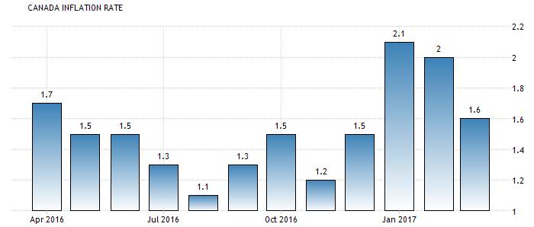

Figure 5.

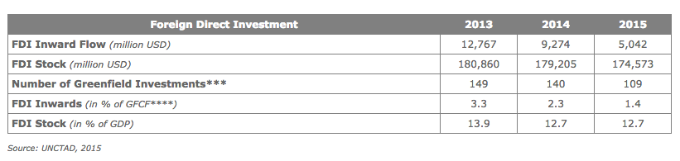

Figure 6.

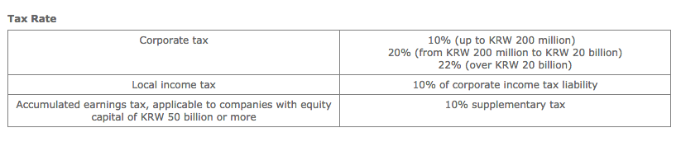

Figure 7.

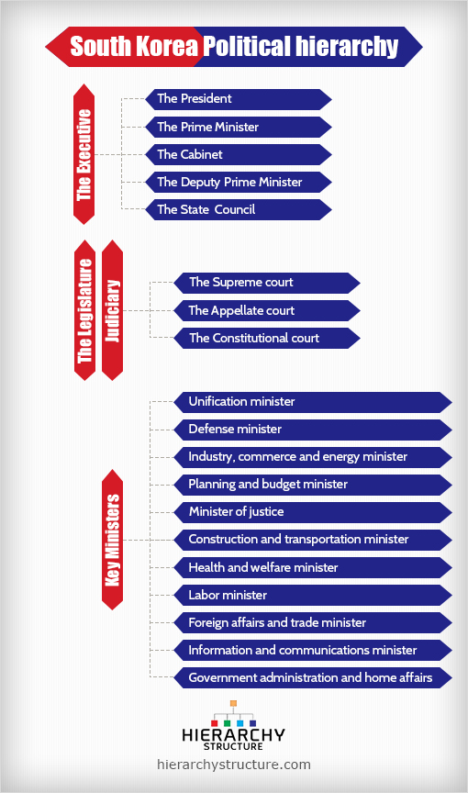

Figure 8.

<http://www.heritage.org/index/country/southkorea>

<http://www.economywatch.com/world_economy/south-korea/structure-of-economy.html>

<http://www.investopedia.com/updates/top-developing-countries/>

<http://www.tradingeconomics.com/south-korea/unemployment-rate>

<http://www.tradingeconomics.com/south-korea/inflation-cpi>

<http://hdr.undp.org/en/data>

<http://www.tradingeconomics.com/south-korea/inflation-cpi>

<http://www.cbc.ca/news/business/wealthiest-1-earn-10-times-more-than-average-canadian-1.1703017>

<http://www.indexmundi.com/south_korea/economy_overview.html>

<http://www.southkoreagovernment.com/economy.htm>

<https://globaledge.msu.edu/countries/south-korea>

<https://en.portal.santandertrade.com/establish-overseas/south-korea/foreign-investment>

<http://www.investkorea.org/en/foreigner/invest.do>

<http://investmentpolicyhub.unctad.org/IIA/country/111/treaty/3486>

http://www.cnbc.com/2017/01/15/south-korea-prosecutor-weighs-economic-impact-of-arrest-of-samsung-chief.html

<http://www.nationsonline.org/oneworld/korea_south_profile.htm>

<http://www.korea4expats.com/article-political-parties-south-korea.html>

<http://www.theglobaleconomy.com/South-Korea/wb_political_stability/>

<http://www.cnn.com/2016/11/02/asia/south-korea-president-scandal-explained/>

<https://www.theguardian.com/world/2017/may/09/moon-jae-in-the-south-korean-pragmatist-who-would-be-presidentc>

<http://www.investopedia.com/terms/c/corruption-perception-index.asp>

<http://www.transparency.org/news/feature/corruption_perceptions_index_2016>

<http://www.business-anti-corruption.com/country-profiles/south-korea>